**Memorandum of Understanding (MOU)   
Kenai River Baseline Water Quality Monitoring   
2025 Renewal**

Table of Contents

Memo: 2025 Memorandum of Understanding 2

Document A: Project Status Summary 3

Document B: Signatories for the 2015 MOU 6

Document C: 2025 Memorandum of Understanding 7

Document D: Signature Page 11

References 12

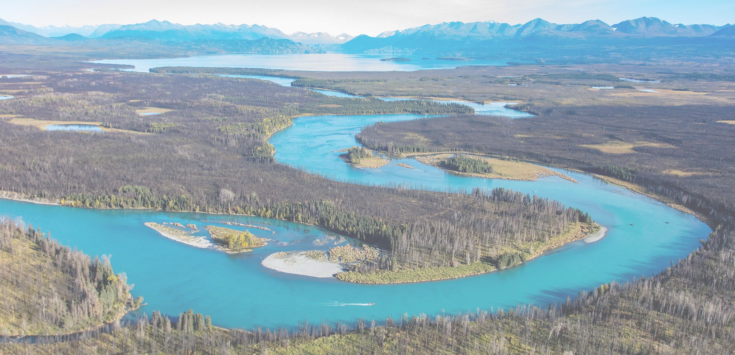

*The Kenai River flows from Skilak Lake. Photo Credit: Ian Reid*

## Memo: 2025 Memorandum of Understanding

January 9, 2025

Dear NAME,

The Kenai River Baseline Water Quality Monitoring program is one of Alaska’s longest-running and most robust efforts to assess water quality in the state. Since the year 2000 the program has partnered with over a dozen government, tribal, private, and non-governmental organizations. Results have provided critical data for management decisions at the local level that help keep the Kenai River thriving and accessible.

The project’s Memorandum of Understanding (MOU) document outlines the roles of partnering organizations, and is due for renewal. We are requesting a renewal signature from your office as confirmation of continued support for this project. The MOU is a non-binding document and does not legally commit any entities or individuals to financial support or management actions.

We are eager to share more about the project with your office and look forward to speaking with you. Additional details and resources are linked on the project [website](https://www.kenaiwatershed.org/kenai-river-baseline-water-quality-monitoring/), as well as in the Project Status Summary attached here.

Thank you for your support and consideration. Sincerely,

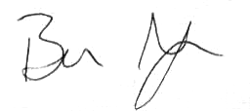

Benjamin Meyer  
Research Coordinator  
Kenai Watershed Forum  
[ben@kenaiwatershed.org](mailto:ben@kenaiwatershed.org)   
(907) 232-0280

Trent Dodson  
Executive Director  
Kenai Watershed Forum  
[executivedirector@kenaiwatershed.org](mailto:executivedirector@kenaiwatershed.org)   
(907) 260-5449 ext. 1206

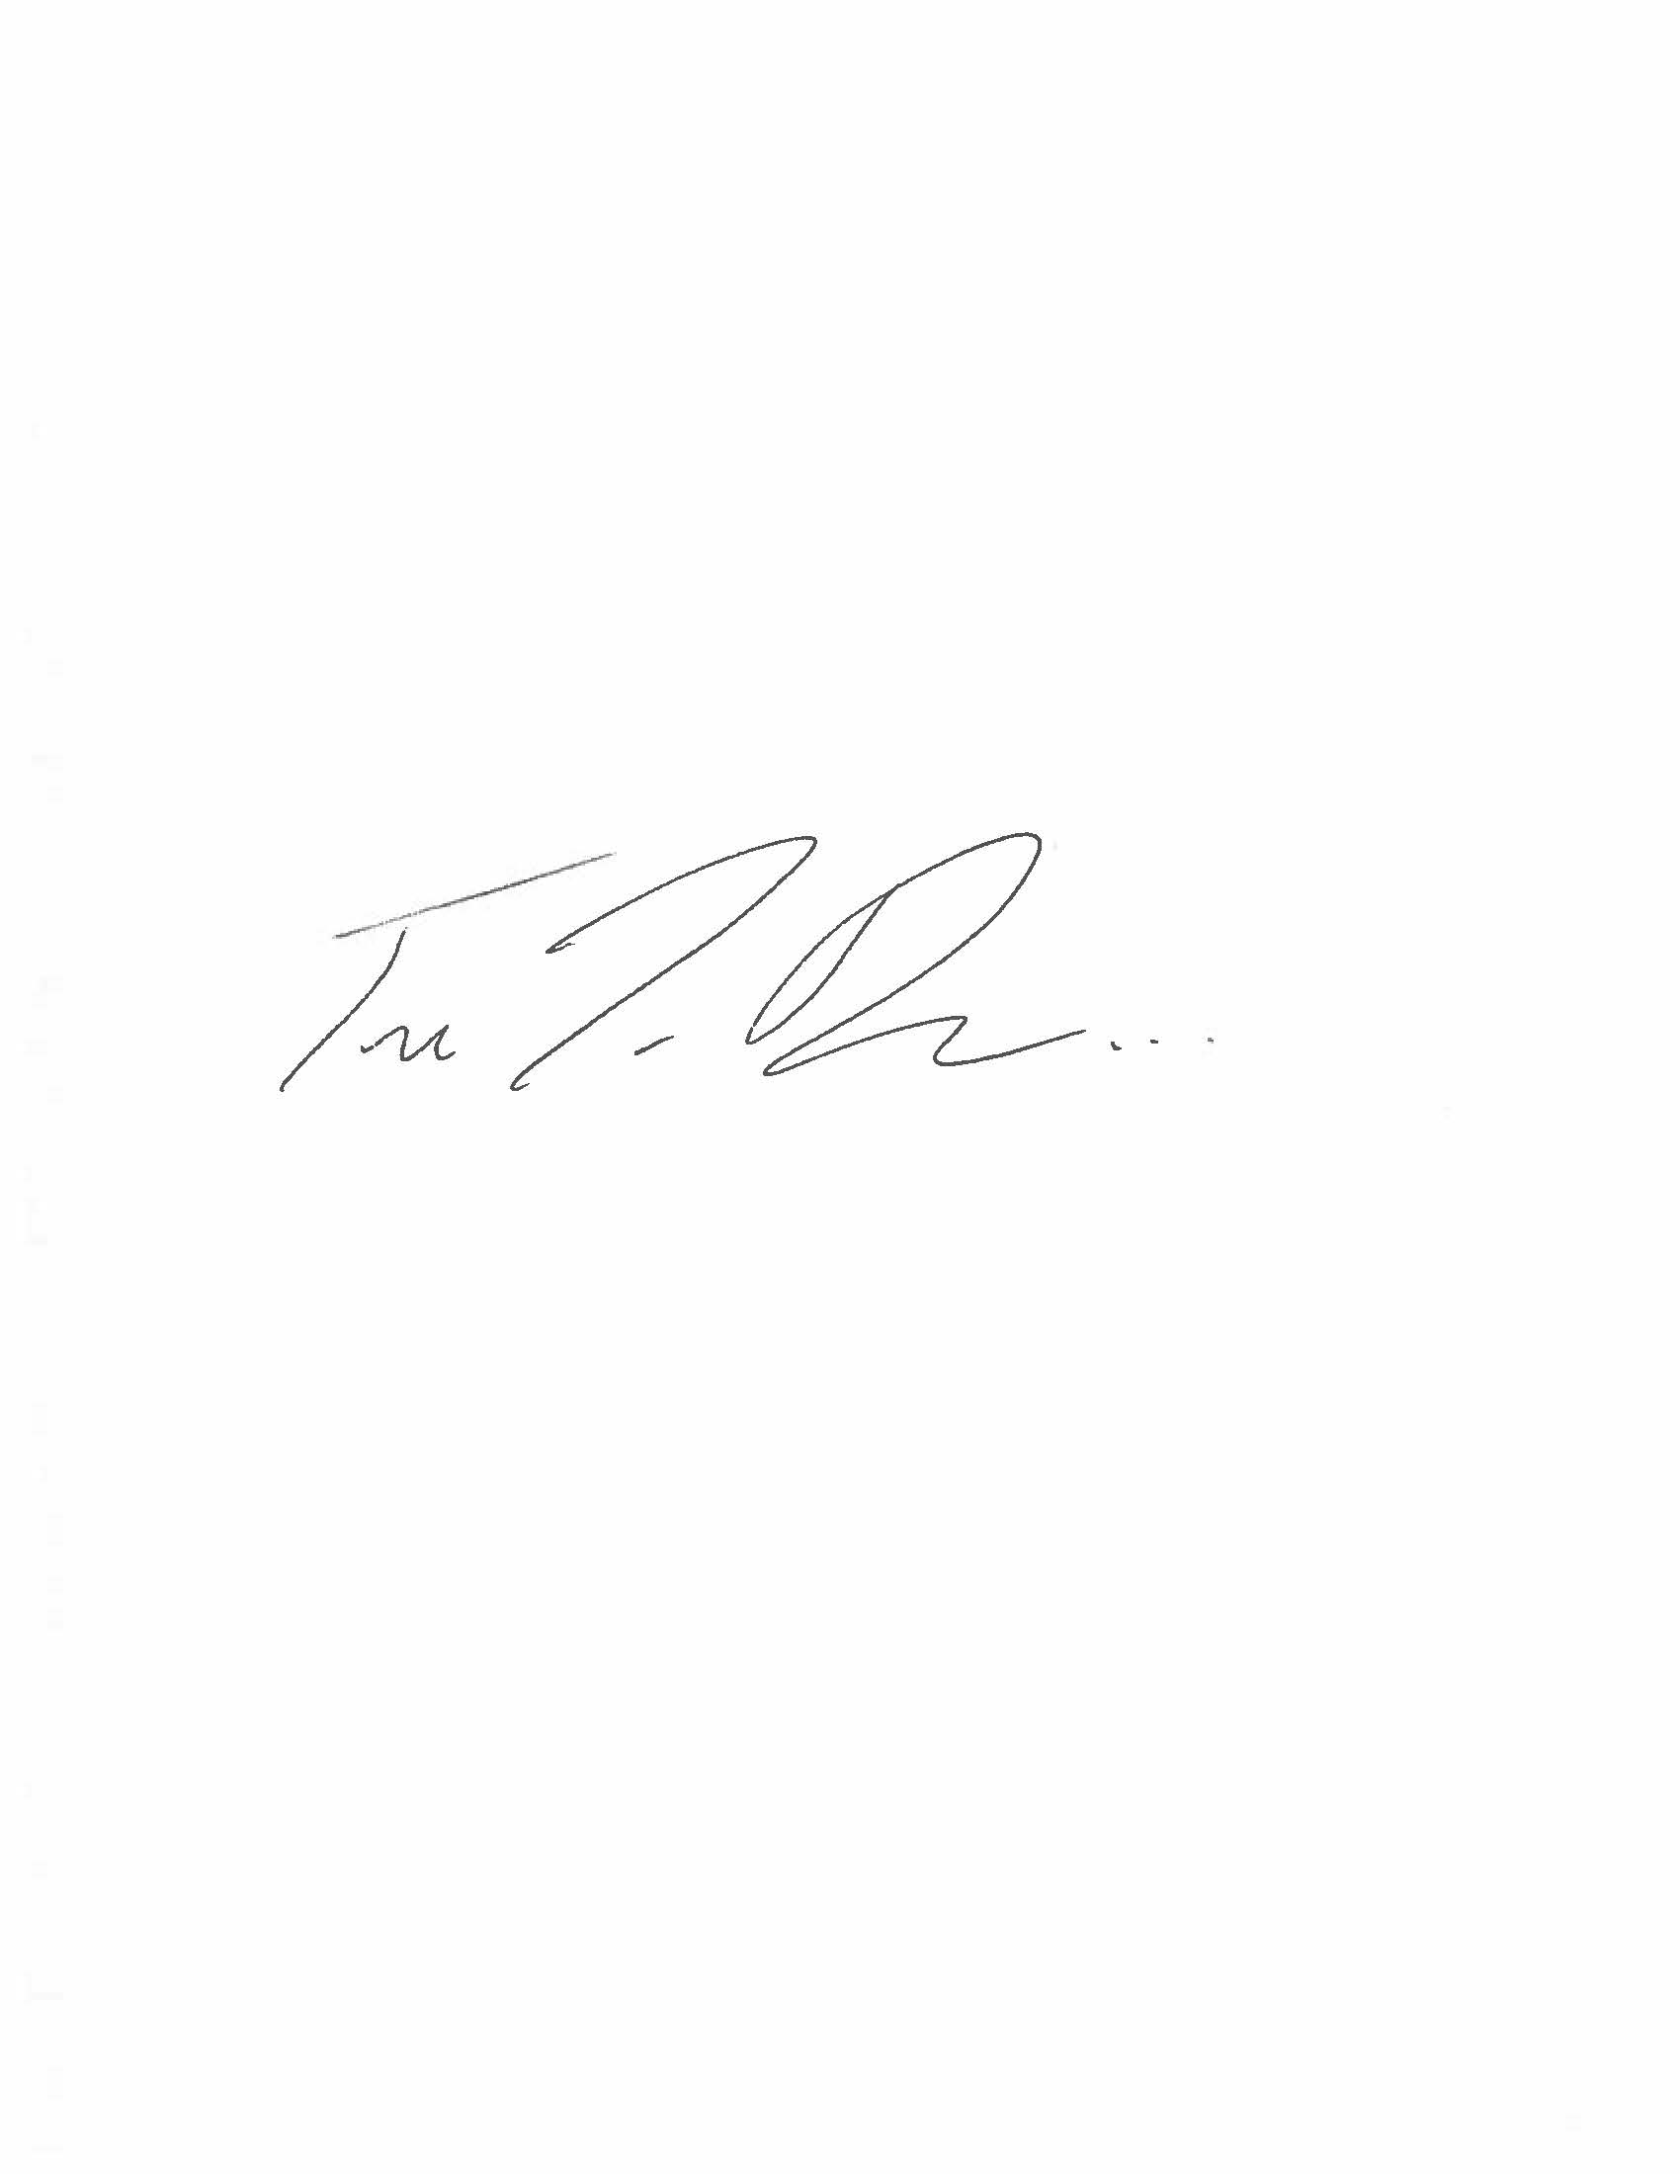

## Document A: Project Status Summary

**January 2025**

**The Kenai River Baseline Water Quality Monitoring Project – 24 years of Community Driven Research**

***Introduction***

The Kenai River in southcentral Alaska is among the worlds most famed, supporting diverse fisheries and industries and the people who rely on them. Since the year 2000 [Kenai Watershed Forum](https://www.kenaiwatershed.org/) has coordinated the efforts of government, tribal, private, and nonprofit partners to monitor water quality trends throughout the river as specified in the Alaska Department of Natural Resources’ 1997 [Kenai River Special Management Area Comprehensive Management Plan](https://dnr.alaska.gov/parks/plans/krsmapln/kenrvpln.htm). The twenty-four year continuous effort has produced a long and robust water quality dataset that is applied to identify and address critical local water management issues. The program serves as a remarkable example of how community partnerships can generate outsized impact.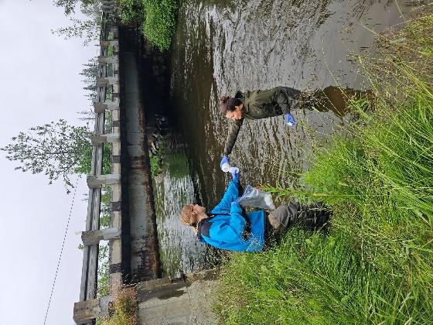

*Collecting a water sample from a tributary of the Kenai River*

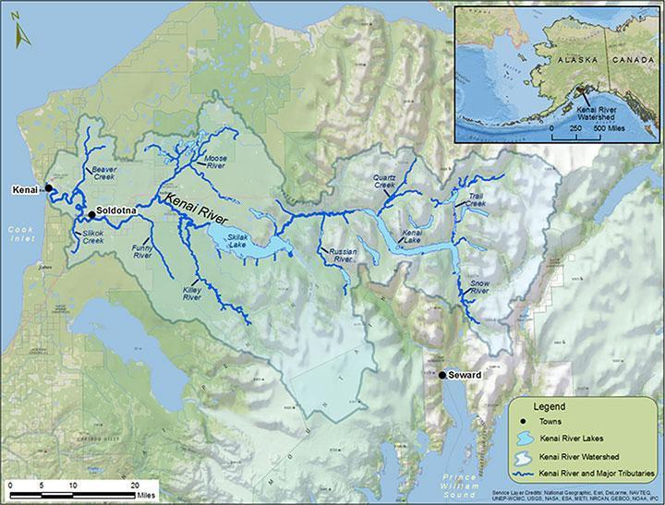

Twice annually, the program measures water quality at twenty-two sites throughout the Kenai River and its tributaries. The project surveys for a diverse list of substances including bacteria, metals, nutrients, fuels, and more. All results are published in the public domain and are assessed against state and federal water quality standards. Comprehensive reports have been published in 2007 and 2016, with another planned for analysis in 2025. Visit the [project website](https://www.kenaiwatershed.org/kenai-river-baseline-water-quality-monitoring/)[1] for details and additional resources.

*Map of the Kenai River watershed in southcentral Alaska (*[*click link for an online interactive version*](https://www.arcgis.com/home/webmap/viewer.html?webmap=d4b8b5150bcd47af827fc16630a7a05d&extent=-152.4449,59.7542,-146.7265,61.3972) *of the map)*

***Inflation Has Reduced Project Purchasing Power***

***As of January 2025, annual project income no longer supports base level expenses. We are tasked with reducing some monitoring and analysis efforts unless income levels increase.***

Over fifteen organizations support monitoring work each year with in-kind and/or financial backing. While the overall level of annual financial contribution has remained relatively steady, a *56% rise in inflation of the US dollar since 2005* has lessened the purchasing power of resources available to the project. In 2022, a one-time contribution of EPA pass-through funds from Kenaitze Indian Tribe allowed the project to continue as planned through 2024, but future years will need to identify additional funds to continue providing the same level of service. Access additional project financial details at <https://kenai-watershed-forum.github.io/kenai-river-wqx/finance_history.html>.

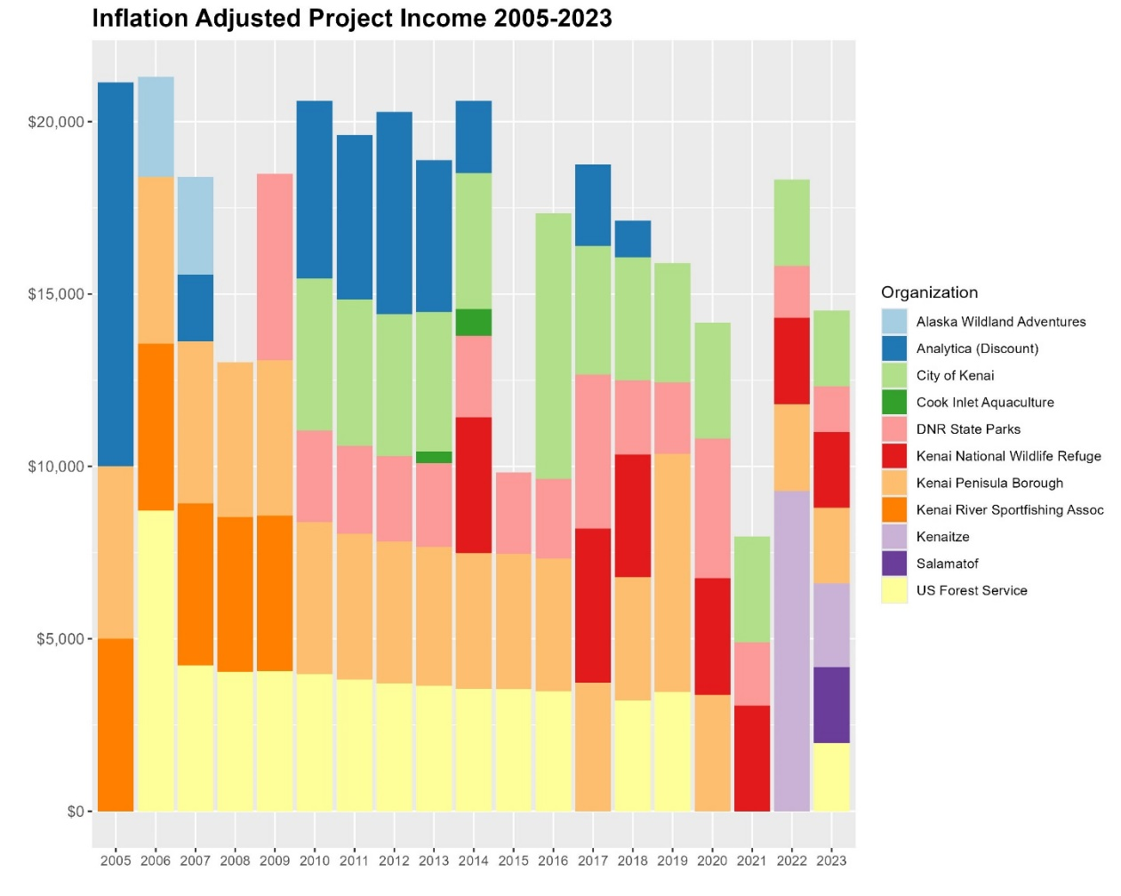

*Inflation-adjusted financial contribution to the Kenai River Baseline Water Quality Monitoring Project 2005 - 2023.*

***Sustaining Future Project Activities***

Kenai Watershed Forum is actively pursuing funding from new public and private sources to support this work, including the U.S. Bureau of Restoration, the ConocoPhillips Community Grants program, and others. However, annual support from existing long-term local partners remains the most viable way to secure this project into the future.

As your organization considers renewing the Memorandum of Understanding (MOU), the level of financial support required to sustain the work will be part of the discussion. *Note that the MOU does not contractually commit any organization to specific financial support.*

We look forward to discussing this work further with your office and are eager to share the next comprehensive report. Thank you for your time and consideration.

***Further Reading and Links***

* Updating Boat Motors Reduces Hydrocarbon Pollution (EPA, 2011)
  + <https://19january2017snapshot.epa.gov/sites/production/files/2015-10/documents/ak_kenai.pdf>
* Kenai River Comprehensive Management Plan (AKDNR, 1997)
  + <https://dnr.alaska.gov/parks/plans/krsmapln/kenrvpln.htm>
* Kenai River Baseline Water Quality Monitoring Project – Homepage (KWF, 2024)
  + <https://www.kenaiwatershed.org/kenai-river-baseline-water-quality-monitoring/>
* Kenai River Baseline Water Quality Monitoring – Presentation to International River Symposium (KWF, 2022)
  + <https://www.youtube.com/watch?v=znROWo6MfAg>

## Document B: Signatories for the 2015 Kenai River Baseline Water Quality Monitoring Project Memorandum of Understanding[2]

* Commissioner, Alaska Department of Environmental Conservation
* Commissioner, Alaska Department of Fish and Game
* Commissioner, Alaska Department of Natural Resources
* Principal, Analytica, Inc.
* Mayor, City of Kenai
* Mayor, City of Soldotna
* Executive Director, Cook Inlet Aquaculture Association
* Mayor, Kenai Peninsula Borough
* Executive Director, Kenaitze Indian Tribe
* Executive Director, Kenai Watershed Forum
* Alaska Regional Director, U.S. Fish and Wildlife Service
* Forest Supervisor, Chugach National Forest

## Document C: 2025 Memorandum of Understanding

**MEMORANDUM OF UNDERSTANDING**

*JANUARY 2025*

BETWEEN

ALASKA DEPARTMENT OF ENVIRONMENTAL CONSERVATION

AND

ALASKA DEPARTMENT OF FISH AND GAME

AND

ALASKA DEPARTMENT OF NATURAL RESOURCES

AND

SGS LABORATORIES, INC.

AND

CITY OF KENAI

AND

CITY OF SOLDOTNA

AND

COOK INLET AQUACULTURE ASSOCIATION

AND

THE KENAI PENINSULA BOROUGH

AND

THE KENAITZE INDIAN TRIBE

AND

SALAMATOF TRIBE

AND

TYONEK TRIBAL CONSERVATION DISTRICT

AND

KENAI WATERSHED FORUM

AND

U.S. FISH AND WILDLIFE SERVICE, ALASKA REGION

AND

U.S. FOREST SERVICE, CHUGACH NATIONAL FOREST

This Memorandum of Understanding between the above-listed parties, hereinafter referred to as Agencies/Organizations, reflects the general policy guidelines within which the Agencies/ Organizations agree to operate in relation to the “[Kenai River Watershed Water Quality Monitoring Program](https://www.kenaiwatershed.org/kenai-river-baseline-water-quality-monitoring)”, hereinafter referred to as the WQ Program.

WHEREAS, Water quality monitoring was identified in the “Kenai River Comprehensive Management Plan”1 adopted December 1997 as an important component to the management of the Kenai River and its health, and

WHEREAS, The goal of the 1998 Framework for Water Quality Monitoring of the Kenai River2 is to provide a water quality monitoring strategy to ensure the environmental integrity of the Kenai River Watershed, and

WHEREAS, Water quality monitoring began in 2000, resulting in data being collected under the WQ Program for 24 years, and

WHEREAS, The water quality data collected under this program has been used to establish baseline conditions, conduct ongoing water quality trend analysis for numerous streams in the Kenai River Watershed and to prepare two water quality reports (years 2007 and 2016) summarizing all data, trends and management implications3–5, and

WHEREAS, The data from this program have been used to identify problems in the Kenai River which have been addressed and resolved, maintaining the health and integrity of the Kenai River, and

WHEREAS, Water quality data from this program have been collected under Quality Assurance Project Plan plans approved by Alaska Department of Environmental Conservation and the U.S. Environmental Protection Agency, and

WHEREAS, The data collected under this project are in the public domain and available to the public, which fosters agency and community understanding of the current and future conditions of the Kenai River, and

WHEREAS, Local, State, and Federal Agencies, and non-governmental organizations party to this Memorandum of Understanding recognize the Kenai River to be important to the human and ecological community of the central Kenai Peninsula, and

WHEREAS, There is a benefit to collecting water quality information for improving the understanding of the Kenai River Watershed, and

WHEREAS, There are benefits in coordinating efforts for the planning, collection, analysis, management and presentation of water quality data, and

WHEREAS, The previous Memorandum of Understanding for the Kenai River Water Quality Monitoring Program signed in 2015 has expired.

NOW, THEREFORE, THE PARTIES DO HEREBY AGREE AS FOLLOWS:

1. To work cooperatively to facilitate a long-term Water Quality Monitoring Program for the Kenai River Watershed.
2. To support the collection and analysis of water samples for the Kenai River Watershed Water Quality sampling effort through funding, in-kind services or other mechanisms to the degree allowed by normal planning and budget constraints and to the extent allowable by applicable laws, regulations and policies.
3. Public access to Memorandum of Understanding must not be limited, except when such records must be kept confidential and would have been exempted from disclosure pursuant to Freedom of Information regulations (5 U.S.C. 552).
4. Modifications within the scope of this Memorandum of Understanding must be made by mutual consent of the parties, by the issuance of a written modification signed and dated by all properly authorized, signatory officials, prior to any changes being performed. Requests for the modification should be made, in writing, at least 30 days prior to implementation of the requested change.
5. Any of the parties, in writing, may terminate this Memorandum of Understanding in whole, or in part, at any time before the date of expiration.
6. The parties to this Memorandum of Understanding agree to be responsible for damages to their own property and injuries to their own employees/volunteers, except for damage/injuries resulting from the fault or negligence of the other party. Any claim for damage to property or persons made against the Government will be pursued in accordance with the provision of the Federal Tort Claims Act.
7. No member of, or Delegate to, Congress shall be admitted to any share or part of this Memorandum of Understanding, or any benefits that may arise there from; but this provision shall not be construed to extend to this agreement if made a corporation for its general benefit.
8. To acknowledge that this Memorandum of Understanding does not:
   1. Limit agencies, local governments, tribes or organizations in the collection or use of data for purposes other than that of the cooperative effort;
   2. Authorize any of the parties to obligate or transfer funds. Specific projects or activities that involve the transfer of funds, services, or property among the parties require execution of separate agreements and are contingent upon the availability of appropriated funds.
   3. Intend to conflict with federal, state, or local laws or regulations, with an understanding if there are conflicts, this agreement will be amended at the first opportunity to bring it into conformance with applicable laws or regulations; and
   4. Intend to enlarge or diminish the responsibilities or statutory authority of any of the signatories or any other party over the management of water or its resources within the Kenai River drainage.

This Memorandum of Understanding will be effective through December 31st, 2030, at which time all parties will reevaluate the need and desire to enter into any subsequent understanding. Once all parties have signed and returned the Memorandum of Understanding, each party will receive a copy of the signatory pages.

By signature below, each party certifies that the individual listed in the individual parties is authorized to act in their respective areas for matters related to this Memorandum of Understanding. In witness whereof, the parties hereto have executed this Memorandum of Understanding as of the last date written below.

## 

## Document D: Signature Page

*See separate attached document in email.*

## References

1. AKDNR. *Kenai River Comprehensive Management Plan*. <https://www.kenaifishpartnership.org/wp-content/uploads/2021/10/krsma_1997_editable_sm.pdf> (1997).

2. The Nature Conservancy of Alaska. *1998 Framework for Water Quality Monitoring of the Kenai River*. <https://www.kenaiwatershed.org/wp-content/uploads/2024/09/1998-Framework-for-Water-Quality-Monitoring-of-the-Kenai-River-.pdf> (1998).

3. Guerron Orejuela, E. *Water Quality Assessment of the Kenai River Watershed from July 2000 to July 2014*. <https://dec.alaska.gov/media/16756/kenai-river-baseline-monitoring-report-final-zncuappendix.pdf> (2016).

4. McCard, J. J. *Water Quality Assessment of the Kenai River Watershed from July 2000 to July 2006*. <https://www.kenaiwatershed.org/wp-content/uploads/2024/09/Water-Quality-Assessment-of-the-Kenai-River-Watershed-from-July-2000-to-July-2006.pdf> (2007).

5. KWF. Kenai River Baseline Water Quality Monitoring. <https://www.kenaiwatershed.org/kenai-river-baseline-water-quality-monitoring/> (2024).

1. <https://www.kenaiwatershed.org/kenai-river-baseline-water-quality-monitoring/>
2. View at <https://bit.ly/kwf_mou_2015>